# **Operators**

1. Write a program to find the area and perimeter of a Rectangle/Circle.

#include <stdio.h>  
#define PI 3.14

*int* main()

{

*int* usrInp;

*float* length, breadth, radius, areaRectangle, perimeterRectangle, areaCircle, perimeterCircle;

printf("Select Shape: \n 1: Rectangle\n 2: circle\n");

scanf("%d", &usrInp);

if (usrInp == 1) {

*/* to find area and perimeter of rectangle */*

printf("Enter Length: ");

scanf("%f", &length);

printf("Enter Breadth: ");

scanf("%f", &breadth);

areaRectangle = (length * breadth);

perimeterRectangle = (2 * (length + breadth));

printf("The Area of the Rectangle is: %.2f\n", areaRectangle);

printf("The Perimeter of the Rectangle is: %.2f\n", perimeterRectangle);

}

else if (usrInp == 2) {

*/* to find area and perimeter of circle */*

printf("Enter Radius: ");

scanf("%f", &radius);

areaCircle = (PI * radius * radius);

perimeterCircle = (2 * PI * radius);

printf("The Area of the Circle is: %.2f\n", areaCircle);

printf("The Perimeter of the Circle is: %.2f\n", perimeterCircle);

}

else {

printf("Try again!\n");

}

return 0;

}

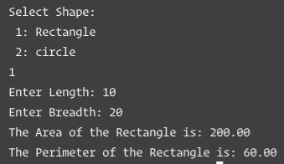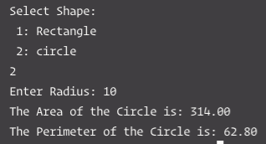

1. Write a program to calculate the volume of a sphere.

#include<stdio.h>

#define PI 3.14

*int* main()

{

*float* radius, volume;

printf("Enter Radius: ");

scanf("%f", &radius);

volume = ((4* PI * radius * radius * radius) / 3);

printf("The Volume of the Sphere is %.2f\n", volume);

return 0;

}



1. Write a program to find the square and cube of a number.

#include<stdio.h>

*int* main()

{

*float* x, sq, cu;

printf("Enter a number: ");

scanf("%f", &x);

sq = (x * x);

cu = (x * x * x);

printf("The square of %.2f is %.2f\n", x, sq);

printf("The cube of %.2f is %.2f\n", x, cu);

return 0;

}

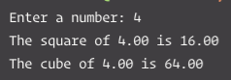

1. Write a problem to convert a given temperature in Celsius to Fahrenheit by using formula.

F = 1.8 * Celsius + 32

#include<stdio.h>

*int* main()

{

*float* cel, far;

printf("Enter the temperature in Celcius: ");

scanf("%f", &cel);

far = (1.8 * cel) + 32;

printf ("The temperature in Farenheit is: %.1f\n", far);

return 0;

}



1. Rajesh’s basic salary is input through the keyboard. His dearness allowance is 40% of basic salary and house rent allowance is 20% of basic salary. Write a program to calculate his grass salary.

# include <stdio.h>

*int* main()

{

*float* bp, da, hra, grpay;

*/* bp = basic pay,*

*da = dearness allowance,*

*hra = house rent allowance,*

*grpay = gross pay. */*

printf("\n Rajesh, Enter Basic Pay: ");

scanf("%f",&bp);

da = (0.4 * bp);

hra = (0.2 * bp);

grpay = (bp + da + hra);

printf("Basic Pay = %.1f\n",bp);

printf("Dearness Allowance = %.1f\n",da);

printf("House Rent Allowance = %.1f\n",hra);

printf("Gross Salary/Pay= %.1f\n",grpay);

return 0;

}

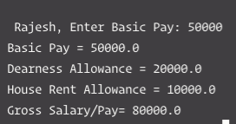

1. Write a program to interchange the value of the two variables without using a third variable.

#include<stdio.h>

*int* main()

{

*int* a, b;

printf("Enter 'A': ");

scanf("%d", &a);

printf("Enter 'B': ");

scanf("%d", &b);

printf("Before Interchanging, the value of \nA: %d\nB: %d\n", a, b);

a = a + b;

b = a - b;

a = a - b;

printf("After Interchanging, the value of \nA: %d\nB: %d\n", a, b);

return 0;

}

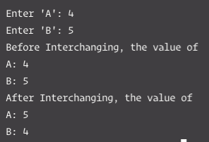

1. Write a program to rotate the content of three variables without using the fourth variable.

#include<stdio.h>

*int* main()

{

*int* a, b, c;

printf("Enter 'A': ");

scanf("%d", &a);

printf("Enter 'B': ");

scanf("%d", &b);

printf("Enter 'C': ");

scanf("%d", &c);

printf("Before Rotating, the value of \nA: %d\nB: %d\nC: %d\n", a, b, c);

a = a + b + c;

b = ((a + b) - a);

c = (a - (b + c));

a = (a - (b + c));

printf("After Rotating, the value of \nA: %d\nB: %d\nC: %d\n", a, b, c);

return 0;

}

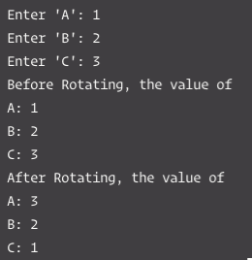

1. Write a program that converts inches to centimeters. For example, if the user enters 16.9 for a length in inches, the output would be 42.926 cm (One inch equals 2.54 centimeter).

#include<stdio.h>

*int* main()

{

*float* cm, inch;

printf("Enter the length in inch(es): ");

scanf("%f", &inch);

cm = 2.54 * inch;

printf("%.3f inch(es) is equal to %.3f centimeter(s)\n", inch, cm);

return 0;

}

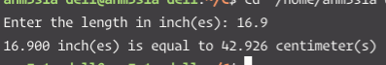

1. Write a program to exchange the digits of a two digit number.

#include<stdio.h>

*int* main()

{

*int* number, x, y, exchange;

printf("Enter a two digit number: ");

scanf("%d",&number);

printf("Before Exchange, the number is: %d\n", number);

x = number % 10;

y = number / 10;

exchange = (x * 10) + y;

printf("After Exchange the number is: %d\n", exchange);

return 0;

}

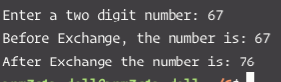

1. Write a program to accept a 4 digit number and display sum of digits and reverse of a number.

#include<stdio.h>

*int* main()

{

*int* digit1, digit2, digit3, digit4, sum;

printf("Enter 4 digits (Press ENTER each time after every digit unit you get all 4): \n");

scanf("%d%d%d%d", &digit1, &digit2, &digit3, &digit4);

sum = (digit1 + digit2 + digit3 + digit4);

printf("The 4 digit number is: %d%d%d%d\n", digit1, digit2, digit3, digit4);

printf("The sum of the 4 digit number is: %d\n", sum);

printf("The reverse format of the 4 digit number is: %d%d%d%d\n", digit4, digit3, digit2, digit1);

return 0;

}

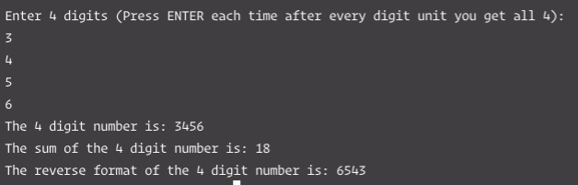

1. Write a program to accept a 4 digit number and to check whether it is a perfect square number or not.

#include<stdio.h>

*int* main()

{

*int* number, i;

printf("Enter a four digit number: ");

scanf("%d", &number);

for(i = 0; i <= number; i++)

{

if(number == i * i)

{

printf("%d is a perfect square\n", number);

return 0;

}

}

printf("%d is not a perfect square\n", number);

return 0;

}

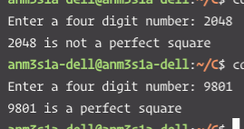

1. Write a program to accept a number and to check whether it is even or odd number.

#include<stdio.h>

*int* main()

{

*int* number;

printf("Enter a number: ");

scanf("%d", &number);

if (number % 2 == 0) */*That is if the remainder is 0*/* {

printf ("It's an even number\n");

}

else {

printf ("It's an odd number\n");

}

return 0;

}

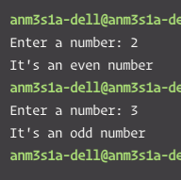

1. Write a program to display absolute value of an entered number using conditional operator.

#include<stdio.h>

*int* main()

{

*int* numberInput;

printf("Enter a number: ");

scanf("%d", &numberInput);

if (numberInput < 0) {

numberInput = numberInput * (-1);

}

else {

numberInput = numberInput;

}

printf("The absolute value of the entered number is %d\n", numberInput);

return 0;

}

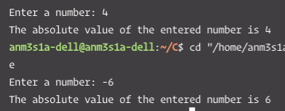

1. Write a program to find maximum of three numbers using conditional operator.

#include <stdio.h>

*int* main()

{

*double* num1, num2, num3;

printf("Enter three different numbers: \n");

scanf("%lf %lf %lf", &num1, &num2, &num3);

if (num1 >= num2 && num1 >= num3) {

printf("%.2f is the largest number\n", num1);

}

if (num2 >= num1 && num2 >= num3) {

printf("%.2f is the largest number\n", num2);

}

if (num3 >= num1 && num3 >= num2) {

printf("%.2f is the largest number\n", num3);

}

return 0;

}

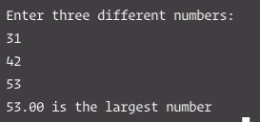

Name: Atharva Auti

FE 15

Roll no.: 01